Dear friends:
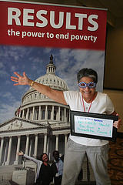
In September, UNICEF announced that 6 million fewer children will die this year than in 1990. In fact, over the last 22 years, the world’s collective action has saved some 90 million children from dying from mostly preventable and treatable causes like measles, malaria, pneumonia, and diarrheal disease. For three decades, RESULTS and RESULTS Educational Fund have been working to support child survival efforts and increase access to quality health care services for the poorest, and we’re proud that our volunteers have played a key role in ensuring that the U.S. has supported policies and increased funding to make this announcement by UNICEF possible. Your support has been vital to our work and to this lifesaving progress.
“I’m a hero because no child should die from a preventable cause.”
While we’re celebrating this heartening news, we know we can’t slow down. We’re ensuring U.S. investment in the GAVI Alliance that, combined with other donor support, will help countries deliver vaccines to a quarter of a billion children by 2015! We’ve renewed our focus on child malnutrition, engaging dozens of new congressional supporters across the political spectrum, because today nearly half of all deaths in children under age five are linked to undernutrition.
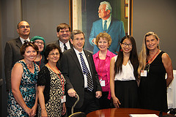
At our International Conference this year, UNICEF Executive Director Anthony Lake applauded our volunteers for their “passion and commitment” and encouraged us to continue to “Educate. Agitate. Organize.” These three words capture the power of our grassroots advocacy. Our volunteers have achieved many victories, and I’d like to share a few of which we are especially proud.
It is clearer than ever that we can be the generation that defeats AIDS, TB, and malaria — but only if we remain ambitious and continue funding the Global Fund to Fight AIDS, Tuberculosis and Malaria, which saves over a million lives each year. The Global Fund’s donor replenishment conference in Washington, D.C. this December will be a pivotal moment — we must invest to accelerate the end of these diseases of poverty or risk losing ground. RESULTS advocates are supporting a new three-year U.S. commitment of up to $5 billion that will potentially leverage $10 billion from other donors. RESULTS advocates have been building support for this replenishment all year — for example, they secured the signatures of 101 House members on a letter to the Appropriations Committee in support of $1.65 billion for the Global Fund for 2014, a critical show of support as the U.S. makes its final decision.
Illinois advocates with Sen. Kirk.
No child anywhere should go to bed hungry, but it is sadly more than 1 in 5 children in the U.S. face this risk. SNAP (the Supplemental Nutrition Assistance Program) is America’s most important anti-hunger investment. SNAP lifted 4 million people out of poverty in 2012. Almost 75 percent of SNAP participants are families with children, and more than 25 percent of participants are in households with seniors or people with disabilities. SNAP beneficiaries can’t afford DC lobbyists, which is why RESULTS advocates are determined to educate, agitate, and organize on their behalf. This year, Congress has offered different proposals to slash spending for SNAP, including a House passed proposal that would mean 4 million people losing access to SNAP. RESULTS volunteers have made hundreds of phone calls, published over 100 pieces of media, and held more than 80 meetings with congressman and hundreds with their staff to defend SNAP from harmful and unjust cuts.
We are proud of what we’ve accomplished with your support of our highly effective model. But we want to do more — and we must: The World Bank set a goal this year for the world to end extreme poverty by 2030. RESULTS will play a pivotal role to ensure that the U.S. does our part, and we know we need to empower more advocates to create impactful, long-lasting change so the end of extreme poverty by 2030 is a reality.
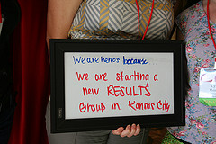
We’re now focusing energy and resources to start new RESULTS chapters so that there are even more trained, supported, and empowered volunteers — our Everyday Heroes — throughout the U.S. Our expansion goals are simple but ambitious: expand from 38 to all 50 states and from half to at least two-thirds of congressional districts by the end of 2015. We aim to create 15 new chapters in 2013 alone, and leverage the participation of 70 new youth leaders who attended our International Conference this past year.
We can’t lose our momentum, which is why I’m asking for your support of our 2013 Annual Campaign.
Our goal is to raise $33,000 by the end of the year. A donation today will provide much-needed funding to provide our volunteers with the training and support they need to continue their advocacy, as well as ensure we continue to expand our presence and impact across the country. We’re grateful for every gift, whether it is $25, $50, $100, $250, $500, or a personally meaningful amount. Please consider starting or increasing a monthly donation if an automatic gift is convenient for you, as that offers predictable and sustained support.
Thank you so much for being part of our successes and for your generosity and commitment. We wouldn’t be able to do our work without you, and I am excited about the things we’ll accomplish together in 2014.

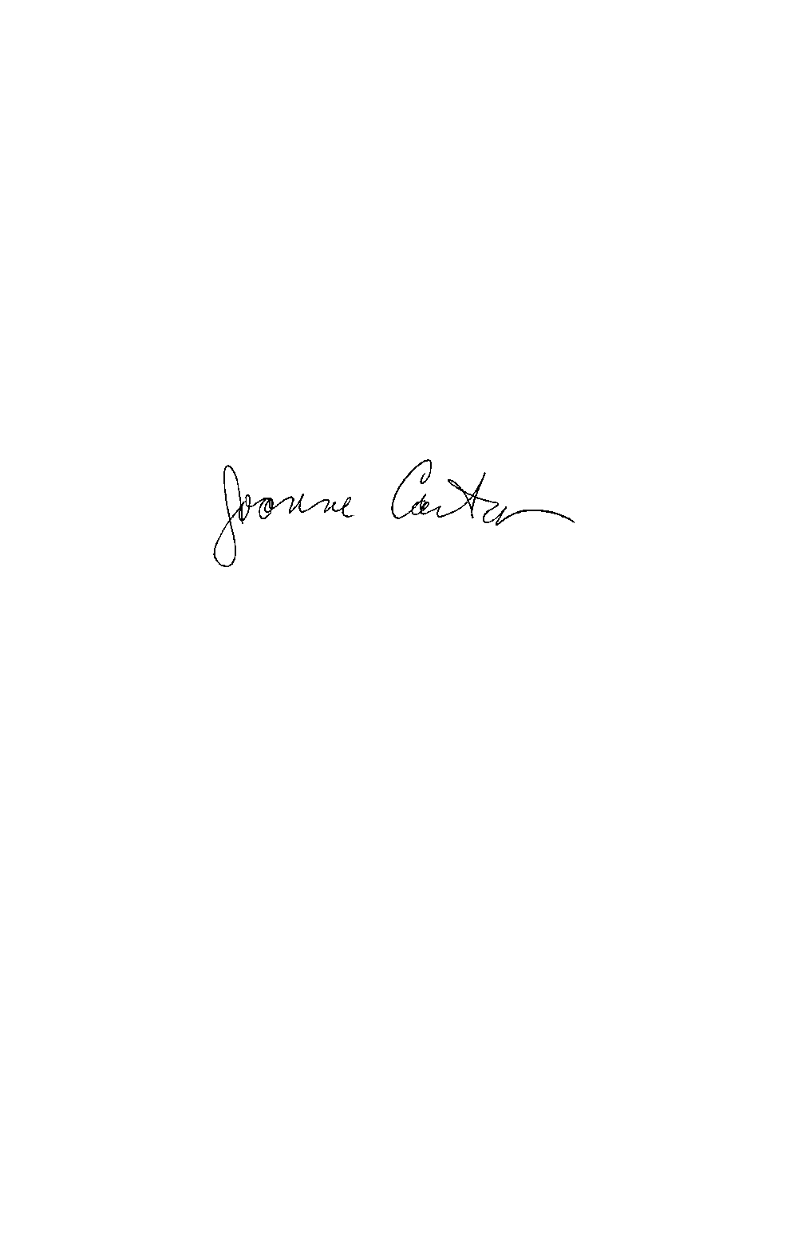
In partnership,

Joanne Carter
Executive Director

PS: We hope you will also consider joining the Legacy Fund by making a planned gift to RESULTS/REF. These legacy gifts take many forms and many offer financial and tax saving benefits. All are greatly appreciated and leave a lasting legacy that helps safeguard the future work of RESULTS/REF. I invite you to reach out to our development manager, Jen Maurer, at jmaurer@results.org or (201) 333-8376 for more information.

State Registrations: FLORIDA: A COPY OF THE OFFICIAL REGISTRATION AND FINANCIAL INFORMATION MAY BE OBTAINED FROM THE DIVISION OF CONSUMER SERVICES BY CALLING TOLL-FREE (800-435-7352) WITHIN THE STATE. REGISTRATION DOES NOT IMPLY ENDORSEMENT, APPROVAL, OR RECOMMENDATION BY THE STATE. (Registration #CH33878/CH33887) 20113006692 20113006693 CHR.0010765 CHR.055275 CH009249 CHOO9325 01060798 448-446-5 448-448-1 22020 22021 051997 CO8872 C08873 CO-066-11 CO-110-11 19126 19127 CH3370000 CH3369700 SL006457 SL006459 95-3747267 42208 42218 39831 39832 9704438 9704439 P19885 P19886 8141056-CHAR 6555684-CHAR 9716 30088 11969-800 11970-800 CS48625 T48627 135154079 135136988

